**Creating and using a Shared Library in JENKINS**

**1)Created two repositories**

**i)jenkins-shared-library**

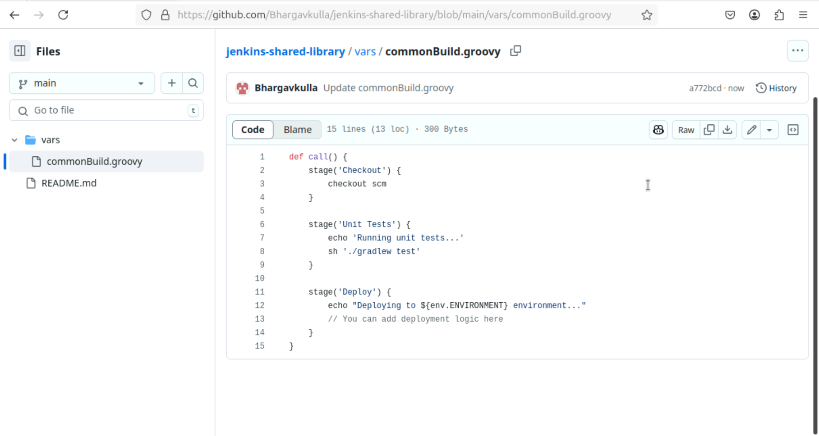

**ii)jenkins-shared which contains vars/commonGroovy file**

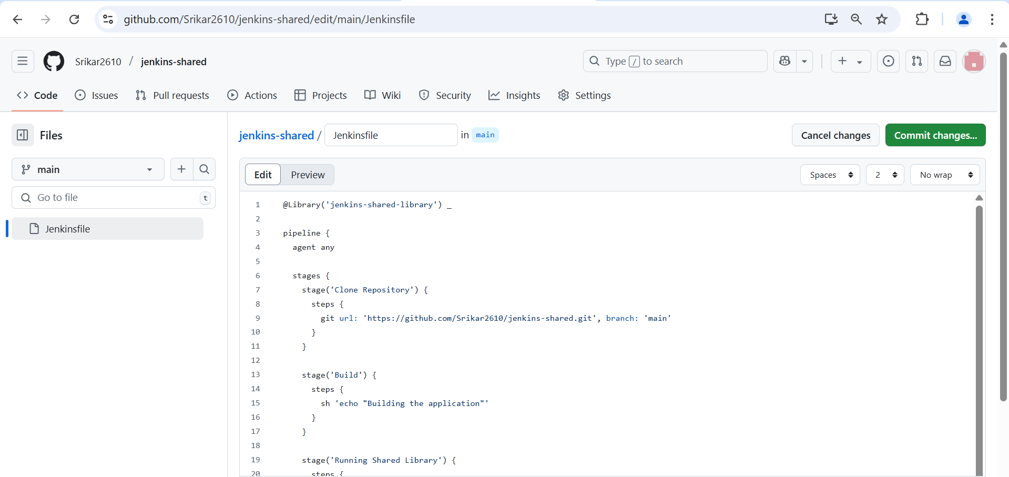

**2)And then added the sharedlibrary in the configure in System Configuration and then Save/Apply it**

**3) Created a pipeline myservice**

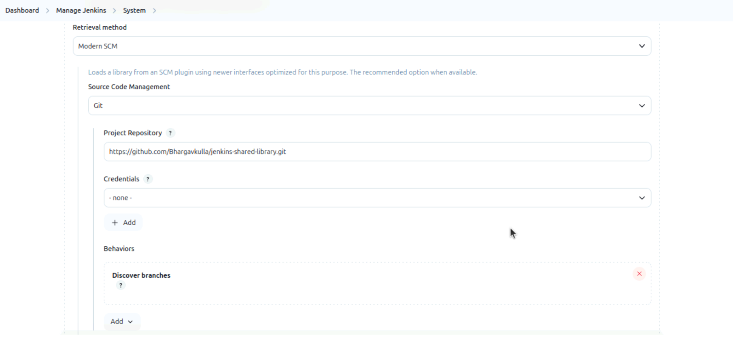

**4)Next created a pipeline for myservice-build and started building**

**OUTPUT:**

